Name: Apau Anita Ama Dzidzor 21st October, 2010
Registration №: SM/SMS/10/0017 Physics practical
EXPERIMENT 8
The water equivalent of a calorimeter
Aim
To determine the water equivalent of a calorimeter.
Apparatus
Copper calorimeter with outer jacket, stirrer made from copper wire, thermometer, beaker, ice.
Diagram
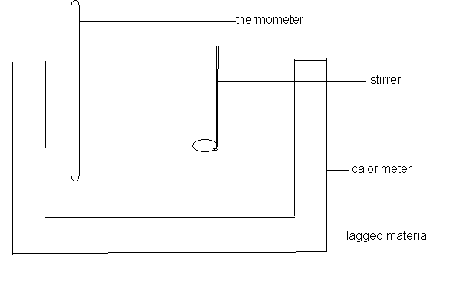

Theory
Heat is the name given to energy in the process of transfer from one body to another as a result of temperature difference between them. Once heat has been transferred to a body or substance, it ceases to be heat and instead becomes internal molecular energy. The S.I unit of energy is the joule.
In this experiment a lagged calorimeter was used this was done to prevent the unnecessary loss of heat. The heat gained by the calorimeter and cold water is equal to the heat loss by the warm water. The water equivalence of a calorimeter is the measure of the quantity of heat required to raise the temperature of the calorimeter to make it one degree warmer in other words it is the number of grams of water which require the same amount of heat to cause a given change in temperature that is required to reproduce an equal change in the temperature of the thinner vessel with the stirrer and thermometer.

Method
The calorimeter and the stirrer are weighed. The ice-cold water is poured into the until it is about one thirds and then it is weighed. It is then put into it’s outer jacket and it is left to stand until it acquires a tempereature about 5℃ below room temperature. While it is left to stand water is heated up in a beaker until it’s temperature is about 15℃ above room temperature. The burner is the4n removed from below the beaker. Some of the warm water from the beaker into the calorimeter until it is two thirds full. It is then stirred and the highest temperature reached is the recorded. The calorimeter is the weighed together with the mixture.

TABLE OF VALUES
Reading |  | Values
Weight Calorimeter and Stirrer | M_{O} | 83.554g
Weight of Calorimeter + Stirrer + Cold water | M₁ | 133.548g
Weight of Calorimeter + Stirrer +Mixture M₂ | M₂ | 184.160g
Initial temperature of Coldwater | θ₁ | 21℃
Initial temperature of warm water | θ₂ | 41℃
Final temperature of mixture | θ₃ | 30℃

Calculations
Let the water equivalent of the calorimeter and the stirrer=w
Heat gained by the calorimeter and cold water=Heat lost by warm water
(M₁- M₀ +w)(θ₃ – θ₁) = (M₂ -M₁) (θ₂ - θ₃)
w = (M₂-M₁) (θ₂- θ₃) - (M₁- M₀)
(θ ₃ – θ ₁)

w = (184.160- 133.548)g - (41˚C - 30˚C) – (133.548 – 83.554) g
(30˚C - 21˚C)
w = (50.612g) (11˚C) – (49.994g)
(9˚C)
w = 556.732g℃ – (49.994g)
9℃
w= 11.865g

Discussions
From the above calculations the water equivalence of a calorimeter which is the measure of the quantity of heat required to raise the temperature of the calorimeter to make it one degree warmer was found out to be 11.865g. This value may not be too accurate due to some minor errors that might have occurred during the experiment.
Source s of error
1. Errors can occur when the water is not transferred from the beaker to the calorimeter with care.
2.Heat can be lost when the calorimeter jacket is not lagged.
PRECAUTIONS
- The calorimeter jacket should be lagged to prevent the undue loss of heat.
- It was ensured that all temperatures were recorded accurately as possible.

CONCLUSION
The water equivalence of a calorimeter was found out to be 11.865g.

REFERENCES
RAYMOND A. SERWAY, JERRY S. FAUGHN (COLLEGE PHYSICS), 6TH EDITION 2003. HARCOURT COLLEGE PUBLISHER.
YOUNG FREEDMAN, (UNIVERSITY PHYSICS) 9TH SDITION, WESLEY PUBLISHING COMPANY,.
NELKON MICHAEL, PARKER PHILIP, (ADVANCED LEVEL PHYSICS) 7TH EDITION

